**1.Create table statement for CLIENT_MASTER, PRODUCT_MASTER and SALEMAN_MASTER table:**

create table CLIENT_MASTER

(

 CLIENTNO varchar2(6),

 NAME varchar22(20),

 ADDRESS1 varchar2(30) NULL,

 ADDRESS2 varchar2(30) NULL,

 CITY varchar2(15),

 PINCODE number(8),

 STATE varchar2(15),

 BALDUE number(10,2)

);

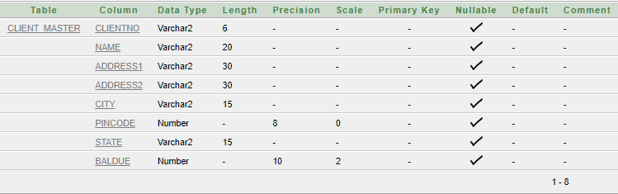

create table PRODUCT_MASTER

(

 PRODUCTNO varchar2(6),

 DESCRIPTION varchar2(15),

 PROFITPERCENT number(4,2),

 UNITMEASURE varchar2(10),

 QTYONHAND number(8),

 REORDERLVL number(8),

 SELLPRICE number(8,2),

 COSTPRICE number(8,2)

);

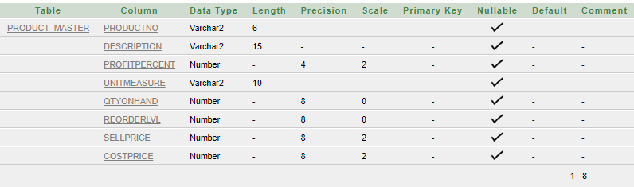

create table SALEMAN_MASTER

(

 SALEMANNO varchar2(6),

 SALEMANNAME varchar2(20),

 ADDRESS1 varchar2(30),

 ADDRESS2 varchar2(30),

 CITY varchar2(30),

 PINCODE number (8),

 STATE varchar2(20),

 SALAME number(8,2),

 TGTTOGET number(6, 2),

 YTDSALES number(6,2),

 REMARKS varchar2(60)

);

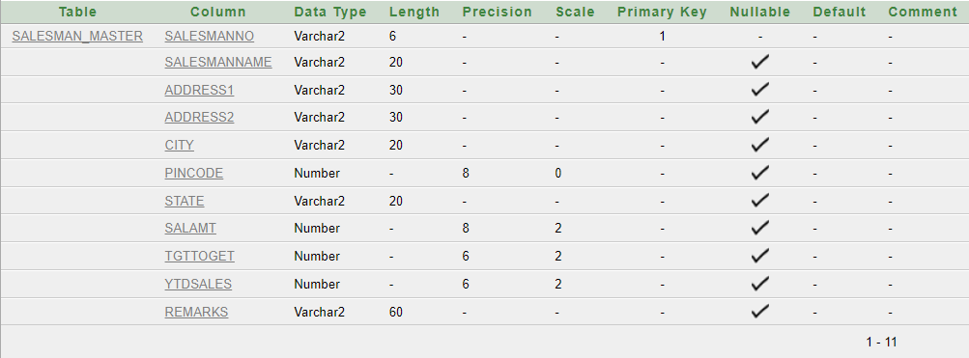

**2.a) Insert Statement for CLIENT_MASTER table:**

insert into CLIENT_MASTER values('C00001','Ivan Bayross',NULL,NULL,'Mumbai',400054,'Maharashtra',15000);

insert into CLIENT_MASTER values('C00002','Mamta Muzumdar',NULL,NULL,'Madras',780001,'Tamil Nadu',0);

insert into CLIENT_MASTER values('C00003','Chhaya Bankar',NULL,NULL,'Mumbai',400057,'Maharashtra',5000);

insert into CLIENT_MASTER values('C00004','Ashwini Joshi',NULL,NULL,'Bangalore',560001,'Karnataka',0);

insert into CLIENT_MASTER values('C00005','Hansel Colaco',NULL,NULL,'Mumbai',400060,'Maharashtra',2000);

insert into CLIENT_MASTER values('C00006','Deepak Sharma',NULL,NULL,'Mangalore',560050,'Karnataka',0);

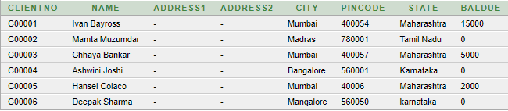

**2.b) Insert Statement for PRODUCT_MASTER table:**

insert into PRODUCT_MASTER values('P00001','T-Shirts',5,'Piece',200,50,350,250);

insert into PRODUCT_MASTER values('P0345','Shirts',6,'Piece',150,50,500,350);

insert into PRODUCT_MASTER values('P06734','Cotton Jeans',5,'Piece',100,20,600,450);

insert into PRODUCT_MASTER values('P07865','Jeans',5,'Piece',100,20,750,500);

insert into PRODUCT_MASTER values('P07868','Trousers',2,'Piece',150,50,850,550);

insert into PRODUCT_MASTER values('P07885','Pull Overs',2.5,'Piece',80,30,700,450);

insert into PRODUCT_MASTER values('P07965','Denim Shirts',4,'Piece',100,40,350,250);

insert into PRODUCT_MASTER values('P07975','Lycra Tops',5,'Piece',70,30,350,175);

insert into PRODUCT_MASTER values('P08865','Skirts',5,'Piece',75,30,450,300);

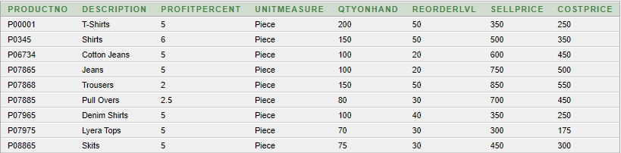

**2.c) Insert Statement for SALEMAN_MASTER table:**

insert into SALEMAN_MASTER value('S00001','Aman','A/14','Worli','Mumbai',400002,'Maharashtra',3000,100,50,'Good');

insert into SALEMAN_MASTER value('S00002','Omkar','65','Nariman','Mumbai',400001,'Maharashtra',3000,200,100,'Good');

insert into SALEMAN_MASTER value('S00003','Raj','P-7','Bandra','Mumbai',400032,'Maharashtra',3000,200,100,'Good');

insert into SALEMAN_MASTER value('S00004','Ashish','A/5','Juhu','Mumbai',400044,'Maharashtra',3000,200,150,'Good');

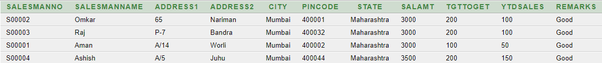

**3.Retrieve record from table:**

**3.a) Find out the names of all the clients:**

select NAME from CLIENT_MASTER;

**Output:**

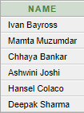

**3.b) Retrieve the entire contents of the CLIENT_MASTER table:**

select * from CLIENT_MASTER;

**Output:**



**3.c) Retrieve the list of the name,city and sate of all the clients.**

select NAME,CITY,STATE from CLIENT_MASTER;

**Output:**

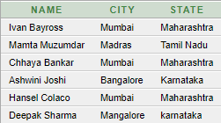

**3.d) List the various products available from the PRODUCT_MASTER.**

select DESCRIPTION from PRODUCT_MASTER;

**Output:**

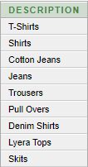

**3.e) List all the clients who are located in Mumbai.**

select NAME from CLIENT_MASTER

where CITY='Mumbai';

**Output:**

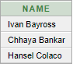

**3.f) Find out the names of salesmen who have a salary equal to Rs.3000**

select SALEMANNAME from SALEMAN_MASTER

where SALAMT=3000;

**Output:**

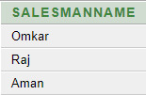

**4.Update record to table:**

**4.a) Change the city of CLIENTNO C00005 to Bangalore**

update CLIENT_MASTER

set CITY='Bangalore'

where CLIENTNO='C00005';

**Output:**

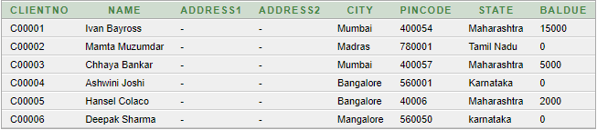

**4.b) Change BALDUE of CLIENTNO C00001 of CLIENT_MASTER**

update CLIENT_MASTER

set BALDUE=1000

where CLIENTNO="C00001";

**Output:**

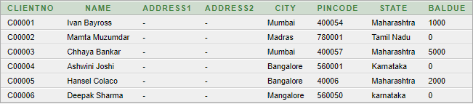

**4.c) Change the cost price of ‘Trouser’ to Rs. 950.00**

update PRODUCT_MASTER

set COSTPRICE=950.00

where DESCRIPTION="Trousers";

**Output:**

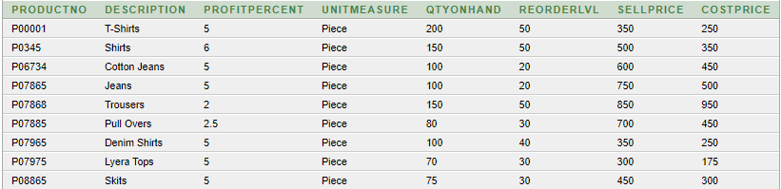

**4.d) Change the city of the salesman to Pune**

update salesman_master

set CITY="Pune";

**Output:**

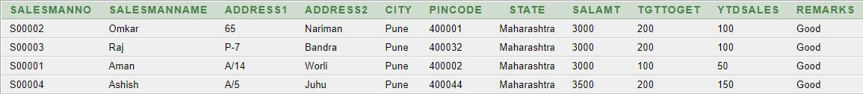

**5.delete record to table:**

**5.a) Delete all salesman from the Salesman_Master whose salaries are equal to Rs.3500**

delete from SALESMAN_MASTER

where SALAMT = 3500;

**Output:**



**5.b) Delete all products from Product_Master where the quantity on hand is equal to 100**

delete from PRODUCT_MASTER

where QTYONHAND = 100;

**Output:**

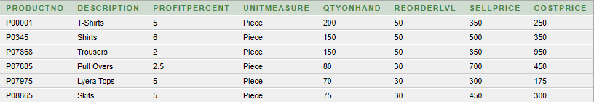

**5.c) Delete from Client_Master where the column state holds the value ‘Tamil Nadu’**

delete from CLIENT_MASTER

where STATE = 'Tamil Nadu';

**Output:**

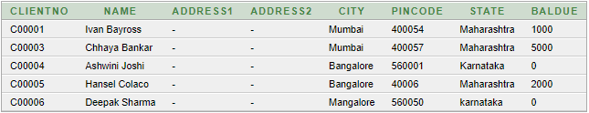

**6.Alter the table structure:**

**6.a) Add column called ‘Telephone’ of data type ‘number’ and size = ‘10’ to the Client_Master table.**

alter table CLIENT_MASTER

add Telephone number(10);

**Output:**

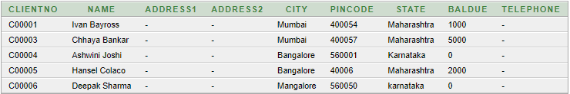

**6.b) Change the size of SellPrice column in Product_Master to 10,2.**

alter table PRODUCT_MASTER

modify SELLPRICE numeric(10,2);

**Output:**

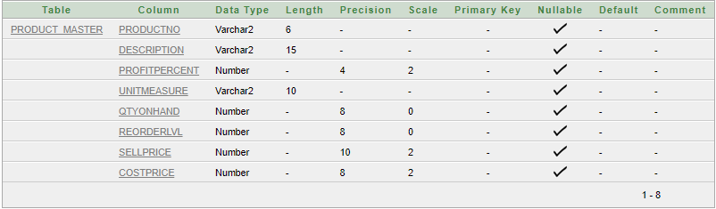

**7.Delete table structure along with the data:**

**7.a)Destroy the table Client_Master along with its data**

drop table CLIENT_MASTER;

**8.Rename table:**

**8.a)Change the name of the Salesman_Master table to sman_mast**

alter table SALESMAN_MASTER

rename sman_mast;

**CREATE TABLE SALES_ORDER**

**(**

**ORDERNO VARCHAR2(6) PRIMARY KEY CHECK(ORDERNO LIKE 'O%'),**

**CLIENTNO VARCHAR2(6) REFERENCES CLIENT_MASTER,**

**ORDERDATE DATE NOT NULL,**

**DELYADDR VARCHAR2(25),**

**SALESMANNO VARCHAR2(6) REFERENCES SALESMAN_MASTER,**

**DELYTYPE CHAR(1) DEFAULT 'F' CHECK(DELYTYPE IN ('P','F')),**

**BILLYN CHAR(1),DELYDATE DATE,**

**ORDERSTATUS VARCHAR2(10) CHECK (ORDERSTATUS IN('IN PROCESS','FULLFILLED','BACKORDER','CANCELLED'))**

**);**

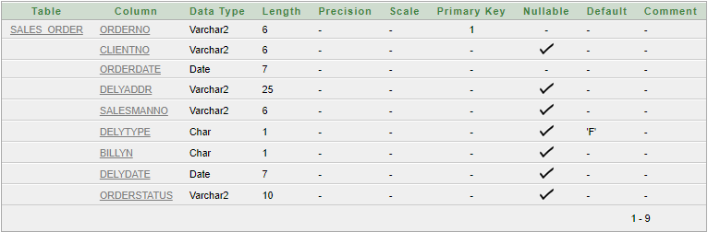

**CREATE TABLE SALES_ORDER_DETAILS**

**(**

**ORDERNO VARCHAR2(6) REFERENCES SALES_ORDER,**

**PRODUCTNO VARCHAR2(6) REFERENCES PRODUCT_MASTER,**

**QTYORDERED NUMBER(8),**

**QTYDISP NUMBER(8),**

**PRODUCTRATE NUMBER(10,2)**

**);**

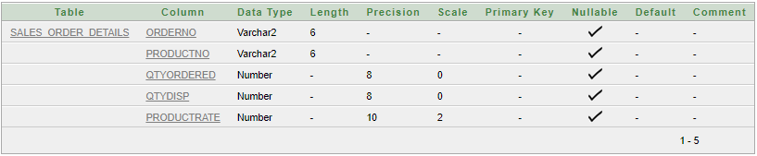

**INSERT INTO SALES_ORDER (ORDERNO,CLIENTNO,ORDERDATE,SALESMANNO,DELYTYPE,BILLYN,DELYDATE,ORDERSTATUS) VALUES ('O19001','C00001','10-JUNE-04','S00001','F','N','20-JULY-02','IN PROCESS');**

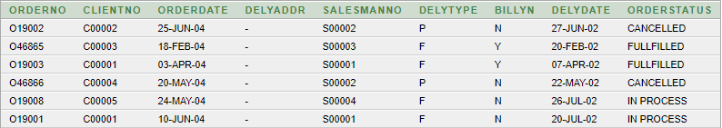

**INSERT INTO SALES_ORDER_DETAILS(ORDERNO,PRODUCTNO,QTYORDERED,QTYDISP,PRODUCTRATE) VALUES ('O19001','P00001',4,4,525);**

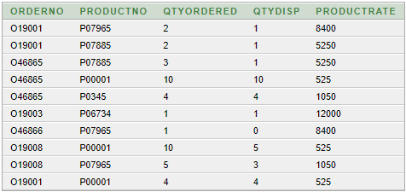

**1.a. List the name of all clients having ‘a’ as the second letter in their names.**

**SELECT NAME FROM CLIENT_MASTER WHERE NAME LIKE '_a%';**



**b. List the clients who stay in a city whose first letter is ‘M’.**

**SELECT NAME FROM CLIENT_MASTER WHERE CITY LIKE 'M%';**

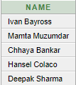

**c. List all clients who stay in ‘Bangalore’ or ‘Mangalore’.**

**SELECT NAME FROM CLIENT_MASTER WHERE CITY = 'Bangalore' OR CITY = 'Mangalore';**

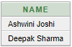

**d. List all clients whose BALDUE is greater than value 10000.**

**SELECT * FROM CLIENT_MASTER WHERE BALDUE > 10000;**



**e. List all information from SALES_ORDER table for orders placed in the month of June.**

**SELECT * FROM SALES_ORDER WHERE TO_CHAR(ORDERDATE,'MM')='06';**



**f. List the order information for CLIENTNO ‘C00001’ and ‘C00002’.**

**SELECT * FROM SALES_ORDER WHERE CLIENTNO='C00001' OR CLIENTNO='C00002';**

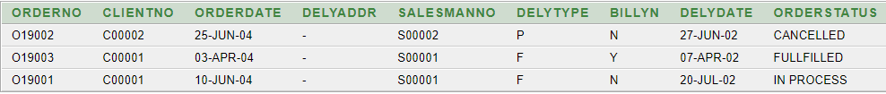

**g. List products whose selling price is greater than 500 and less than or equal to 750.**

**SELECT * FROM PRODUCT_MASTER WHERE SELLPRICE >500 AND SELLPRICE <=750;**

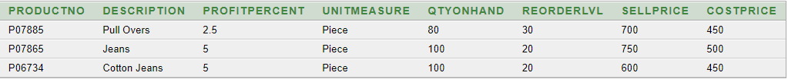

**h. List products whose selling price is more than 500. Calculate a new selling price as, original selling price * .15. Rename the new column in the output of the above query as new_price.**

**SELECT PRODUCTNO, DESCRIPTION, SELLPRICE, SELLPRICE*.15 NEW_PRICE FROM PRODUCT_MASTER WHERE SELLPRICE>500;**

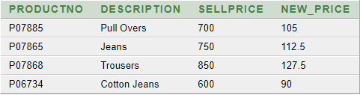

**i. List the names, city and state of clients who are not in the state of ‘Maharashtra’.**

**SELECT NAME, CITY, STATE FROM CLIENT_MASTER WHERE STATE NOT LIKE 'Maharashtra';**

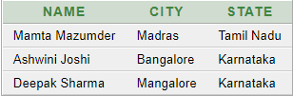

**j. Count the total number of orders.**

**SELECT COUNT (ORDERNO) NUMBEROFORDER FROM SALES_ORDER;**



**k. Calculate the average price of all the products.**

**SELECT AVG (SELLPRICE) FROM PRODUCT_MASTER;**



**l. Determine the maximum and minimum product prices. Rename the output as max_price and min_price respectively.**

**SELECT MAX (SELLPRICE) MAX_PRICE, MIN (SELLPRICE) MIN_PRICE FROM PRODUCT_MASTER;**



**m. Count the number of products having price less than or equal to 500.**

**SELECT COUNT (PRODUCTNO) FROM PRODUCT_MASTER WHERE SELLPRICE<=500;**



**n. List all the products whose QtyOnHand is less than reorder level.**

**SELECT DESCRIPTION FROM PRODUCT_MASTER WHERE QTYONHAND<REORDERLVL;**



**2.a.List the order number and day on which clients placed their order.**

**SELECT ORDERNO, TO_CHAR (ORDERDATE, 'DAY') FROM SALES_ORDER;**

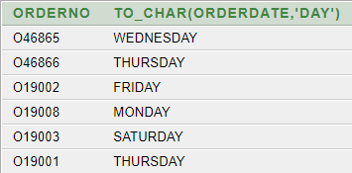

**b.List the month (in alphabets) and date when the orders must be delivered.**

**SELECT TO_CHAR(DELYDATE, 'MONTH'),DELYDATE FROM SALES_ORDER ORDER BY TO_CHAR (DELYDATE, 'MONTH');**

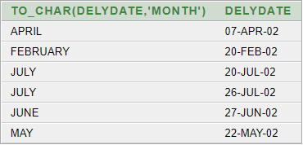

**c.List the OrderDate in the format ‘DD-Month-YY’. e.g. 12-February-02.**

**SELECT TO_CHAR (ORDERDATE, 'DD-MONTH-YY') FROM SALES_ORDER;**

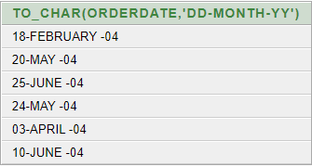

**d.List the date, 15 days after today’s date.**

**SELECT SYSDATE+15 FROM DUAL;**



**1.a. Print the description and total qty sold for each product.**

**SELECT SALES_ORDER_DETAILS.PRODUCTNO, PRODUCT_MASTER.DESCRIPTION, SUM(SALES_ORDER_DETAILS.QTYDISP*SALES_ORDER_DETAILS.PRODUCTRATE) FROM SALES_ORDER_DETAILS, PRODUCT_MASTER WHERE PRODUCT_MASTER.PRODUCTNO=SALES_ORDER_DETAILS.PRODUCTNO GROUP BY SALES_ORDER_DETAILS.PRODUCTNO,PRODUCT_MASTER.DESCRIPTION;**

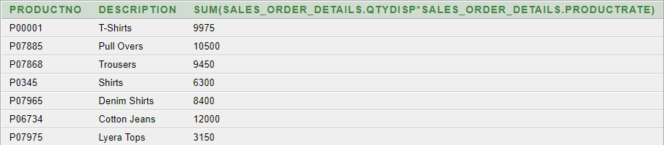

**b.Find the value of each product sold.**

**SELECT DESCRIPTION, SUM(QTYDISP) FROM PRODUCT_MASTER, SALES_ORDER_DETAILS WHERE PRODUCT_MASTER.PRODUCTNO=SALES_ORDER_DETAILS.PRODUCTNO GROUP BY DESCRIPTION;**

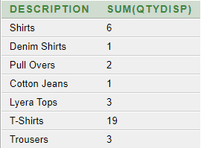

**c.Calculate the average qty sold for each client that has a maximum order value of 15000.00.**

**SELECT CM.CLIENTNO, CM.NAME, AVG (SOD.QTYDISP) FROM SALES_ORDER_DETAILS SOD, CLIENT_MASTER CM, SALES_ORDER SO WHERE CM.CLIENTNO=SO.CLIENTNO AND SO.ORDERNO=SOD.ORDERNO GROUP BY CM.CLIENTNO, NAME HAVING MAX(SOD.QTYORDERED*SOD.PRODUCTRATE)>15000;**

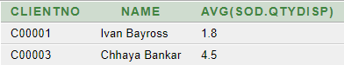

**d. Find out the total of all the billed orders for the month of June.**

**SELECT SO.ORDERNO, SO.ORDERDATE, SUM(SOD.QTYORDERED*SOD.PRODUCTRATE) FROM SALES_ORDER_DETAILS SOD, SALES_ORDER SO WHERE SOD.ORDERNO=SO.ORDERNO AND SO.BILLYN='N' AND TO_CHAR (ORDERDATE,'MON')='JUN' GROUP BY SO.ORDERNO, SO.ORDERDATE;**

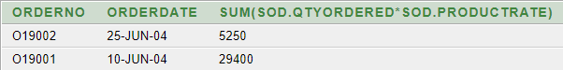

**2.a.Find out the products, which have been sold to 'Ivan Bayross'.**

**SELECT NAME,PRODUCT_MASTER.PRODUCTNO,DESCRIPTION,SALES_ORDER.ORDERNO FROM CLIENT_MASTER,PRODUCT_MASTER,SALES_ORDER,SALES_ORDER_DETAILS WHERE CLIENT_MASTER.NAME = 'Ivan Bayross' AND CLIENT_MASTER.CLIENTNO = SALES_ORDER.CLIENTNO AND SALES_ORDER.ORDERNO = SALES_ORDER_DETAILS.ORDERNO AND SALES_ORDER_DETAILS.PRODUCTNO = PRODUCT_MASTER.PRODUCTNO;**

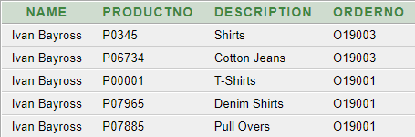

**b.Find out the products and their quantities that will have to be delivered in the current month.**

**SELECT DELYDATE, SALES_ORDER_DETAILS.PRODUCTNO,QTYORDERED,DESCRIPTION FROM SALES_ORDER,SALES_ORDER_DETAILS,PRODUCT_MASTER WHERE SALES_ORDER.ORDERNO = SALES_ORDER_DETAILS.ORDERNO AND SALES_ORDER_DETAILS.PRODUCTNO = PRODUCT_MASTER.PRODUCTNO AND TO_CHAR(SALES_ORDER.DELYDATE,'MM') = TO_CHAR(SYSDATE,'MM');**



**c.List the ProductNo and description of constantly sold (i.e. rapidly moving) products.**

**SELECT PRODUCTNO FROM SALES_ORDER_DETAILS WHERE PRODUCTRATE = (SELECT MAX (PRODUCTRATE) FROM SALES_ORDER_DETAILS );**



**d.Find the names of clients who have purchased ‘Trousers’.**

**SELECT DESCRIPTION,PRODUCT_MASTER.PRODUCTNO,NAME FROM PRODUCT_MASTER,CLIENT_MASTER,SALES_ORDER,SALES_ORDER_DETAILS WHERE DESCRIPTION = 'Trousers' AND PRODUCT_MASTER.PRODUCTNO = SALES_ORDER_DETAILS.PRODUCTNO AND SALES_ORDER_DETAILS.ORDERNO = SALES_ORDER.ORDERNO AND SALES_ORDER.CLIENTNO = CLIENT_MASTER.CLIENTNO;**



**e.List the products and orders from customers who have ordered less than 5 units of ‘Pull Overs’.**

**SELECT PRODUCT_MASTER.PRODUCTNO,ORDERNO FROM PRODUCT_MASTER,SALES_ORDER_DETAILS WHERE DESCRIPTION = 'Pull Overs' AND PRODUCT_MASTER.PRODUCTNO = SALES_ORDER_DETAILS.PRODUCTNO AND QTYORDERED < 5;**

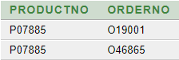

**f. Find the products and their quantities for the orders placed by 'Ivan Bayross' and ‘Mamta Mazumdar’.**

**SELECT NAME,DESCRIPTION,QTYORDERED FROM CLIENT_MASTER,PRODUCT_MASTER,SALES_ORDER,SALES_ORDER_DETAILS WHERE NAME IN('Ivan Bayross','Mamta Mazumder') AND CLIENT_MASTER.CLIENTNO = SALES_ORDER.CLIENTNO AND SALES_ORDER.ORDERNO = SALES_ORDER_DETAILS.ORDERNO AND SALES_ORDER_DETAILS.PRODUCTNO = PRODUCT_MASTER.PRODUCTNO;**

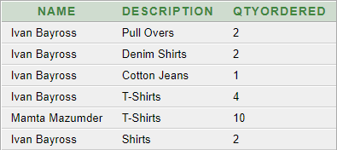

**g.Find the products and their quantities for the orders placed by ClientNo 'C00001' and 'C00002'.**

**SELECT DESCRIPTION,QTYORDERED FROM PRODUCT_MASTER,SALES_ORDER_DETAILS,SALES_ORDER WHERE PRODUCT_MASTER.PRODUCTNO = SALES_ORDER_DETAILS.PRODUCTNO AND SALES_ORDER_DETAILS.ORDERNO = SALES_ORDER.ORDERNO AND CLIENTNO IN('C00001','C00002');**

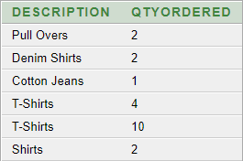

**3.a.Find the ProductNo and description of non-moving products i.e. products not being sold.**

**SELECT SALES_ORDER_DETAILS.PRODUCTNO,DESCRIPTION FROM SALES_ORDER_DETAILS,PRODUCT_MASTER WHERE QTYDISP = 0 AND SALES_ORDER_DETAILS.PRODUCTNO = PRODUCT_MASTER.PRODUCTNO;**

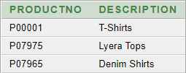

**b.List the customer Name, Address1, Address2, City and PinCode for the client who has placed order no 'O19001'.**

**SELECT NAME,ADDRESS1,ADDRESS2,CITY,PINCODE FROM CLIENT_MASTER,SALES_ORDER WHERE ORDERNO = 'O19001' AND SALES_ORDER.CLIENTNO = CLIENT_MASTER.CLIENTNO;**



**c.List the client names that have placed orders before the month of May’02.**

**SELECT NAME,ORDERDATE FROM CLIENT_MASTER,SALES_ORDER WHERE ORDERDATE < '01-MAY-02' AND SALES_ORDER.CLIENTNO = CLIENT_MASTER.CLIENTNO;**

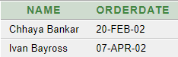

**d.List if the product 'Lycra Top' has been ordered by any client and print the Client_no, Name to whom it was sold.**

**SELECT DESCRIPTION,SALES_ORDER_DETAILS.ORDERNO,CLIENT_MASTER.CLIENTNO,NAME FROM PRODUCT_MASTER, CLIENT_MASTER,SALES_ORDER,SALES_ORDER_DETAILS WHERE DESCRIPTION = 'Lyera Tops' AND PRODUCT_MASTER.PRODUCTNO = SALES_ORDER_DETAILS.PRODUCTNO AND SALES_ORDER_DETAILS.ORDERNO = SALES_ORDER.ORDERNO AND SALES_ORDER.CLIENTNO = CLIENT_MASTER.CLIENTNO;**

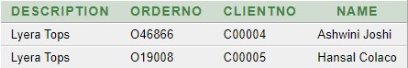

**e.List the names of clients who have placed orders worth Rs. 10000 or more.**

**SELECT NAME FROM CLIENT_MASTER WHERE CLIENTNO IN (SELECT CLIENTNO FROM SALES_ORDER WHERE ORDERNO IN (SELECT ORDERNO FROM SALES_ORDER_DETAILS WHERE (QTYORDERED*PRODUCTRATE) >=10000));**

